Date -

Experiment - 6
JAVA SERVLET:

PROGRAM 1:

AIM:
To create a servlet program that makes Ordered list of four random numbers.

PROGRAM :

MyServlet.java

import javax.servlet.*;
import javax.servlet.http.*;
import java.io.*;

public class MyServlet extends HttpServlet
{
public void doGet(HttpServletRequest request, HttpServletResponse response)
throws ServletException, IOException
{
response.setContentType("text/html");
PrintWriter out = response.getWriter();
out.print("<ul><li>Coffee</li><li>Tea</li><li>Milk </li></ul>");
}
}
web.xml
<web-app>
<servlet>
<servlet-name>List</servlet-name>
<servlet-class>MyServlet</servlet-class>
</servlet>
<servlet-mapping>
<servlet-name>List</servlet-name>
<url-pattern>/List</url-pattern>
</servlet-mapping>
</web-app>

OUTPUT :

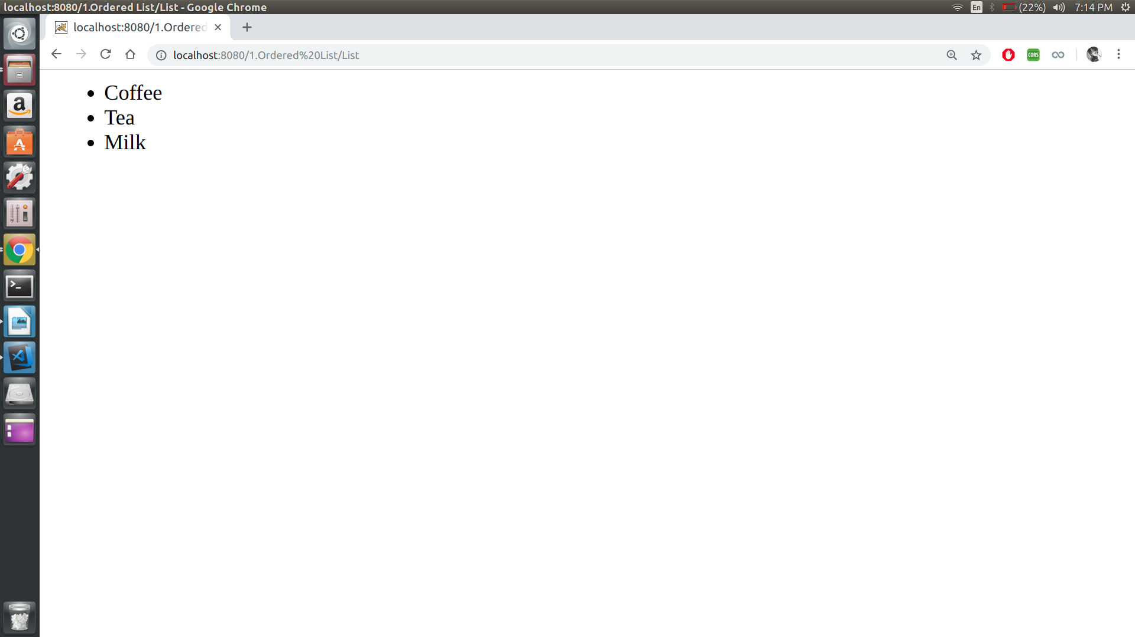
RESULT :
Thus the program is executed and output is obtained.
PROGRAM 2:

Aim:
To create a servlet program that uses a loop to output an HTML table with 20 Rows and 3 columns.

PROGRAM :

MyServlet.java

import javax.servlet.*;
import javax.servlet.http.*;
import java.io.*;

public class MyServlet extends HttpServlet
{
public void doGet(HttpServletRequest request, HttpServletResponse response) throws ServletException, IOException
{
response.setContentType("text/html");
RequestDispatcher view = request.getRequestDispatcher("html/Table.html");
view.forward(request, response);
}
}

Table.html

<html>
<head>
<title>LOL</title>
</head>
<style>
table, th, td {
border: 1px solid black;

}
</style>
<body>
<script>
var mytable = "<table cellpadding=\"0\" cellspacing=\"0\"><tbody><tr>";

for (var i=0; i<20; i++)
{
mytable += "</tr><tr>";
for(var j=0; j<3; j++)
mytable += "<td>(" + i + ", " + j + ")</td>";
}

mytable += "</tr></tbody></table>";

document.write(mytable);
</script>
</body>
</html>

web.xml

<web-app>
<servlet>
<servlet-name>HTML Table</servlet-name>
<servlet-class>MyServlet</servlet-class>
</servlet>
<servlet-mapping>
<servlet-name>HTML Table</servlet-name>
<url-pattern>/table</url-pattern>
</servlet-mapping>
</web-app>

OUTPUT :

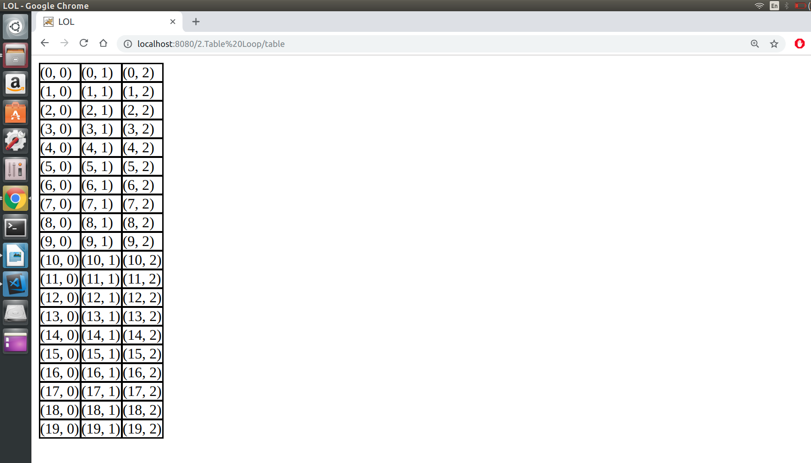

Result:
Thus the program is executed and output is obtained.

PROGRAM 3:

AIM :
To create a servlet program to ake a registration form that collects a Name, Register Number, and email address. Send the data to the servlet that displays it.

PROGRAM :

Form.html

<html>
<body>
<form action = "SimpleForm" method = "GET">
Name: <input type = "text" name = "name">
<br />
Reg. No: <input type = "text" name = "reg_no" />
<br />
Email: <input type = "text" name = "email" />
<br />
<input type = "submit" value = "Submit" />
</form>
</body>
</html>

SimpleForm.java

import java.io.*;
import javax.servlet.*;
import javax.servlet.http.*;

public class SimpleForm extends HttpServlet
{
public void doGet(HttpServletRequest request, HttpServletResponse response)
throws ServletException, IOException
{
response.setContentType("text/html");

PrintWriter out = response.getWriter();
String title = "Submitted Response";
String docType = "";

out.println(docType +
"<html>\n" +
"<head><title>" + title + "</title></head>\n" +
"<body bgcolor = \"#f0f0f0\">\n" +
"<h3 align = \"center\">" + title + "</h1>\n" +
"<ul>\n" +
" <li><b>Name</b>: " + request.getParameter("name") + "\n" +
" <li><b>Reg. No</b>: " + request.getParameter("reg_no") + "\n" +
" <li><b>Email</b>: " + request.getParameter("email") + "\n" +
"</ul>\n" +
"</body>" +
"</html>"
);
}
}

web.xml

<web-app>
<servlet>
<servlet-name>SimpleForm</servlet-name>
<servlet-class>SimpleForm</servlet-class>
</servlet>

<servlet-mapping>
<servlet-name>SimpleForm</servlet-name>
<url-pattern>/SimpleForm</url-pattern>
</servlet-mapping>
</web-app>

OUTPUT :

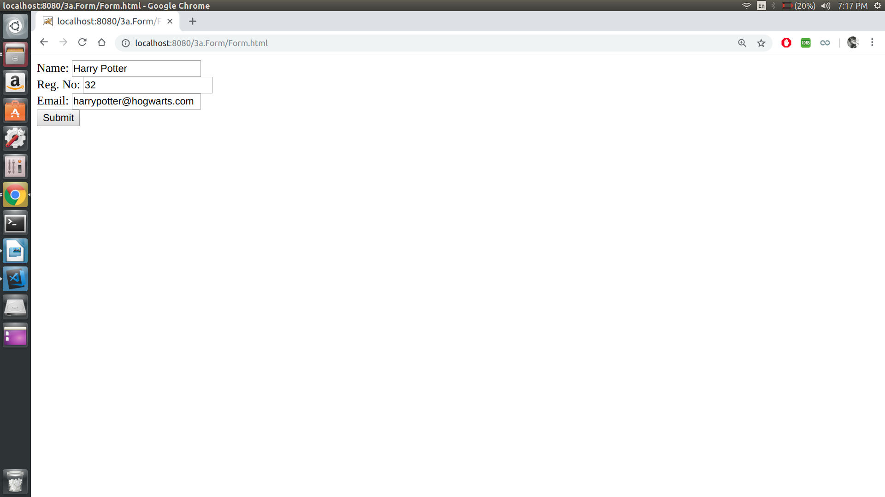
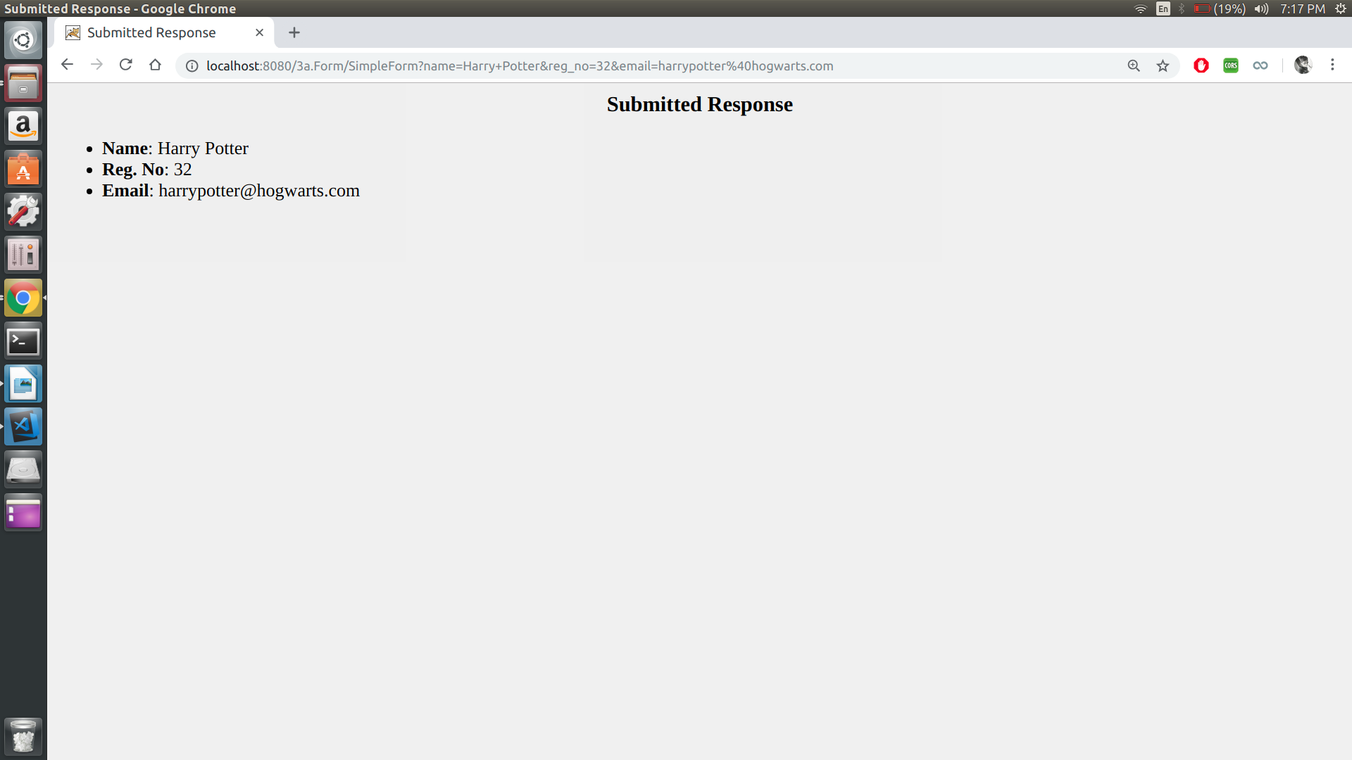

Result:
Thus the program is executed and output is obtained.
PROGRAM 4:

AIM :
To use session tracking to rdo the servlet that says “Welcome Guest” to first-time visitors (with browsing session) and “Welcome back” to repeat visitors

PROGRAM :

SessionTrack.java

import java.io.*;
import javax.servlet.*;
import javax.servlet.http.*;
import java.util.*;

public class SessionTrack extends HttpServlet
{

public void doGet(HttpServletRequest request, HttpServletResponse response)
throws ServletException, IOException
{

HttpSession session = request.getSession(true);

Date createTime = new Date(session.getCreationTime());

Date lastAccessTime = new Date(session.getLastAccessedTime());

String title = "Welcome Back";

if (session.isNew())
{
title = "Welcome to my website";
session.setAttribute("userID", "ABCD");
}
response.setContentType("text/html");
PrintWriter out = response.getWriter();

out.println("<html>\n" +
"<head><title>" + title + "</title></head>\n" +

"<body bgcolor = \"#f0f0f0\">\n" +
"<h1 align = \"center\">" + title + "</h1>\n" +
"</body>"+
"</html>"
);
}
}

web.xml

<web-app>
<servlet>
<servlet-name>SessionTrack</servlet-name>
<servlet-class>SessionTrack</servlet-class>
</servlet>

<servlet-mapping>
<servlet-name>SessionTrack</servlet-name>
<url-pattern>/SessionTrack</url-pattern>
</servlet-mapping>
</web-app>

OUTPUT :

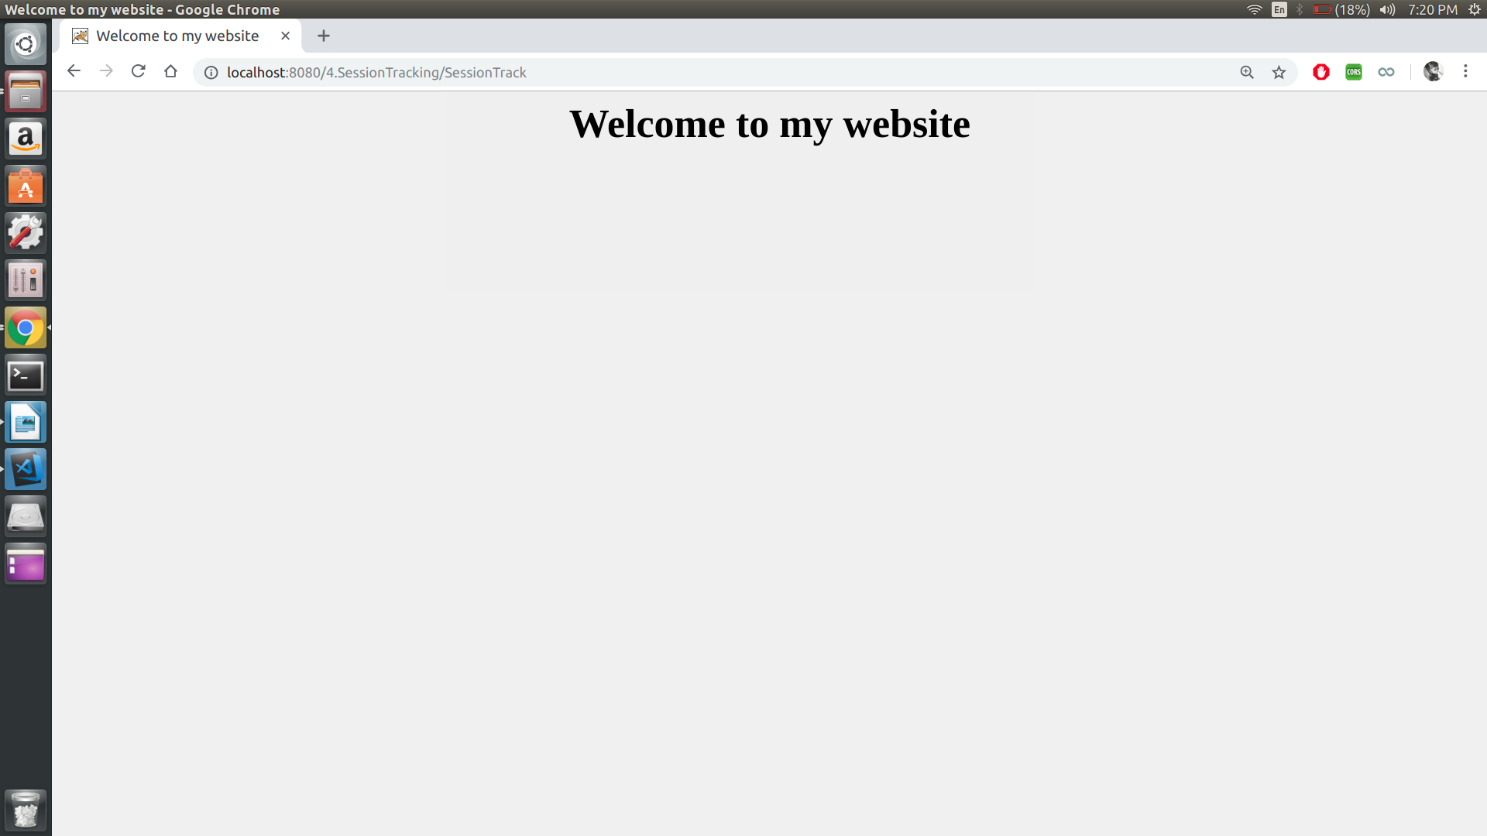
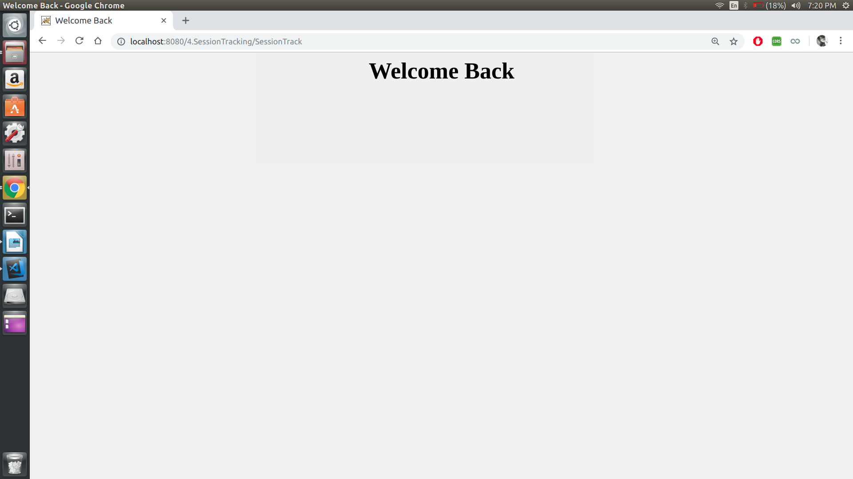

Result:
Thus the program is executed and output is obtained.

PROGRAM 5:

AIM :
To write a servlet that displays the values of Name, Register Number, and emailAddress request parameters. If a parameter is missing and the client is a irst-time visitor, have the servlet list “Unknown for the missing values. If a parameter is missing and the client is a repeat visitor, have the servlet use previously entered values for the missing values

PROGRAM :

Form.html

<html>
<body>
<form action = "Cookie" method = "GET">
Name: <input type = "text" name = "name">
<br />
Reg. No: <input type = "text" name = "reg_no" />
<br />
Email: <input type = "text" name = "email" />
<br />
<input type = "submit" value = "Submit" />
</form>
</body>
</html>

CookieClass.java

import java.io.*;
import javax.servlet.*;
import javax.servlet.http.*;

public class CookieClass extends HttpServlet
{

public void doGet(HttpServletRequest request, HttpServletResponse response)
throws ServletException, IOException
{
response.setContentType("text/html");
PrintWriter out = response.getWriter();

Cookie name = null, reg_no = null, email = null;
Cookie[] cookies = request.getCookies();
cookies = request.getCookies();

if(cookies != null)
{
for (int i = 0; i < cookies.length; i++)
{
if (cookies[i].getName().equals("Name"))
name = cookies[i];
if (cookies[i].getName().equals("Reg_No"))
reg_no = cookies[i];
if (cookies[i].getName().equals("Email"))
email = cookies[i];
}

if (request.getParameter("name").length() == 0)
out.println("Name: " + name.getValue()+"<br />");
else
{
out.println("Name: " + request.getParameter("name")+"<br />");
if (name.getValue().equals("Unknown"))
{
name.setValue(request.getParameter("name"));
response.addCookie(name);
}
}

if (request.getParameter("reg_no").length() == 0)
out.println("Registration Number: " + reg_no.getValue()+"<br />");
else
{
out.println("Registration Number: " + request.getParameter("reg_no")+"<br />");
if (reg_no.getValue().equals("Unknown"))
{
reg_no.setValue(request.getParameter("reg_no"));
response.addCookie(reg_no);
}
}
if (request.getParameter("email").length() == 0)
out.println("Email: " + email.getValue() +"<br />");
else
{
out.println("Email: " + request.getParameter("email")+"<br />");
if (email.getValue().equals("Unknown"))
{
email.setValue(request.getParameter("email"));
response.addCookie(email);
}
}
}

else if(cookies == null)
{
if (request.getParameter("name").length() == 0)
name = new Cookie("Name", "Unknown");
else
name = new Cookie("name", request.getParameter("name"));

if (request.getParameter("reg_no").length() == 0)
reg_no = new Cookie("Reg_No", "Unknown");
else
reg_no = new Cookie("Reg_No", request.getParameter("reg_no"));

if (request.getParameter("email").length() == 0)
email = new Cookie("Email", "Unknown");
else
email = new Cookie("email", request.getParameter("email"));

response.addCookie(name);
response.addCookie(reg_no);
response.addCookie(email);
}
}
}

web.xml

<web-app>
<servlet>
<servlet-name>Cookie</servlet-name>
<servlet-class>CookieClass</servlet-class>
</servlet>

<servlet-mapping>
<servlet-name>Cookie</servlet-name>
<url-pattern>/Cookie</url-pattern>
</servlet-mapping>
</web-app>

OUTPUT :

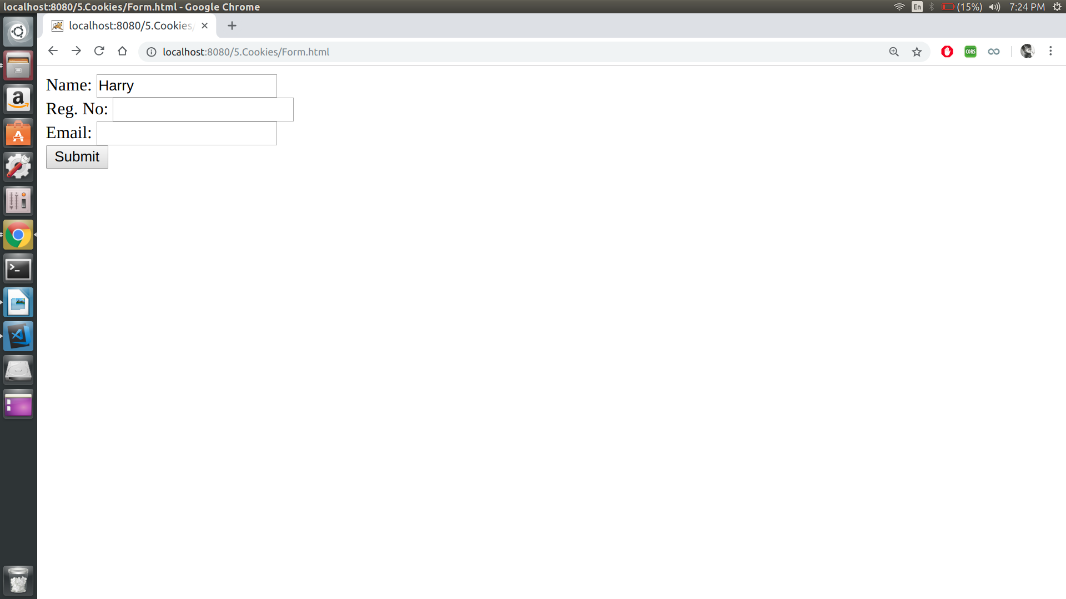
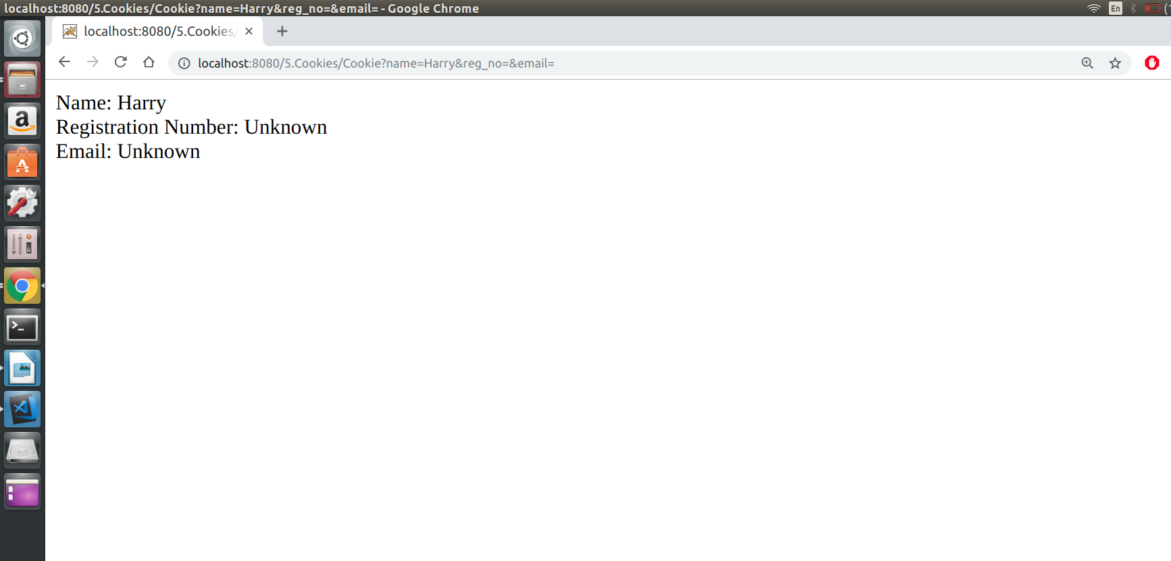
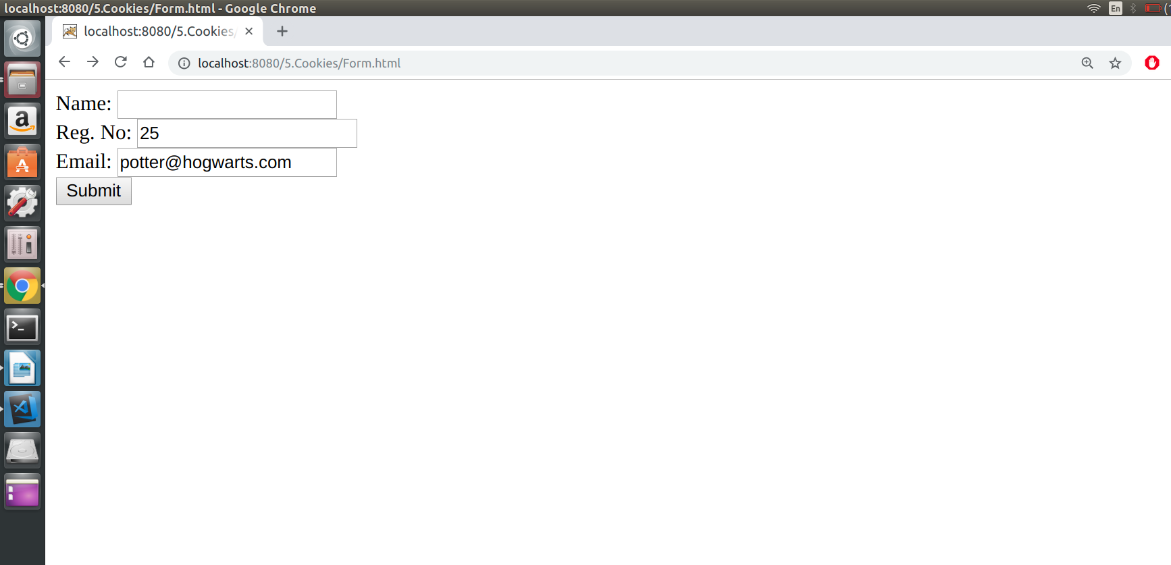
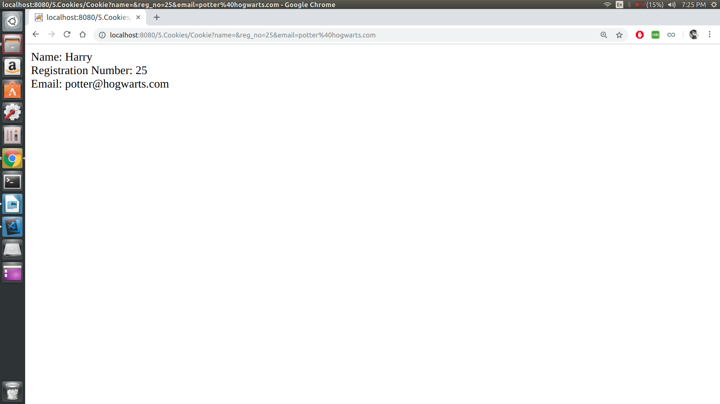

Result:
Thus the program is executed and output is obtained.

PROGRAM 6:

AIM :
To write a servlet program that shows all the request headers. Use a red background and a yellow foreground for Google Chrome users; use a yellow background and a red foreground for Firefox and other users.

PROGRAM :

RequestHeaders.java

import static java.awt.Color.yellow;
import java.io.IOException;
import java.io.PrintWriter;
import java.util.Enumeration;
import javax.servlet.ServletException;
import javax.servlet.http.HttpServlet;
import javax.servlet.http.HttpServletRequest;
import javax.servlet.http.HttpServletResponse;

public class RequestHeader extends HttpServlet {

protected void processRequest(HttpServletRequest request, HttpServletResponse response)
throws ServletException, IOException {

response.setContentType("text/html;charset=UTF-8");
try (PrintWriter out = response.getWriter()) {
out.println("<!DOCTYPE html>");
out.println("<html>");
out.println("<head>");
out.println("<title>Servlet RequestHeader</title>");
out.println("</head>");
final String clientBrowser = getClientBrowser(request);
if (clientBrowser.equals("IE"))
out.println("<body bgcolor= 'yellow' text='red'>");
else
out.println("<body bgcolor = 'red' text='yello'>");
out.println("<h1>Servlet RequestHeader at " + request.getContextPath() + "</h1>");
Enumeration<String> headerNames = request.getHeaderNames();
while (headerNames.hasMoreElements()) {
String headerName = headerNames.nextElement();
out.print("Header Name: <em>" + headerName);
String headerValue = request.getHeader(headerName);
out.print("</em>, Header Value: <em>" + headerValue);
out.println("</em><br/>");
}
out.println("<h3> The client browser is : " + clientBrowser + "</h3>");

out.println("</body>");
out.println("</html>");
}
}

public String getClientBrowser(HttpServletRequest request) {
final String browserDetails = request.getHeader("User-Agent");
final String user = browserDetails.toLowerCase();

String browser = "";

if (user.contains("msie")) {
String substring = browserDetails.substring(browserDetails.indexOf("MSIE")).split(";")[0];
browser = substring.split(" ")[0].replace("MSIE", "IE") + "-" + substring.split(" ")[1];
} else if (user.contains("safari") && user.contains("version")) {
browser = (browserDetails.substring(browserDetails.indexOf("Safari")).split(" ")[0]).split("/")[0] + "-"
+ (browserDetails.substring(browserDetails.indexOf("Version")).split(" ")[0]).split("/")[1];
} else if (user.contains("opr") || user.contains("opera")) {
if (user.contains("opera"))
browser = (browserDetails.substring(browserDetails.indexOf("Opera")).split(" ")[0]).split("/")[0] + "-"
+ (browserDetails.substring(browserDetails.indexOf("Version")).split(" ")[0]).split("/")[1];
else if (user.contains("opr"))
browser = ((browserDetails.substring(browserDetails.indexOf("OPR")).split(" ")[0]).replace("/", "-"))
.replace("OPR", "Opera");
} else if (user.contains("chrome")) {
browser = (browserDetails.substring(browserDetails.indexOf("Chrome")).split(" ")[0]).replace("/", "-");
} else if ((user.indexOf("mozilla/7.0") > -1) || (user.indexOf("netscape6") != -1)
|| (user.indexOf("mozilla/4.7") != -1) || (user.indexOf("mozilla/4.78") != -1)
|| (user.indexOf("mozilla/4.08") != -1) || (user.indexOf("mozilla/3") != -1)) {
browser = "Netscape-?";

} else if (user.contains("firefox")) {
browser = (browserDetails.substring(browserDetails.indexOf("Firefox")).split(" ")[0]).replace("/", "-");
} else if (user.contains("rv")) {
browser = "IE";
} else {
browser = "UnKnown, More-Info: " + browserDetails;
}

return browser;
}

@Override
protected void doGet(HttpServletRequest request, HttpServletResponse response)
throws ServletException, IOException {
processRequest(request, response);
}

@Override
protected void doPost(HttpServletRequest request, HttpServletResponse response)
throws ServletException, IOException {
processRequest(request, response);
}

@Override
public String getServletInfo() {
return "Short description";
}

}

web.xml

<web-app>
<servlet>
<servlet-name>myservlet</servlet-name>
<servlet-class>RequestHeader</servlet-class>
</servlet>
<servlet-mapping>
<servlet-name>myservlet</servlet-name>
<url-pattern>/head</url-pattern>
</servlet-mapping>
</web-app>

OUTPUT :

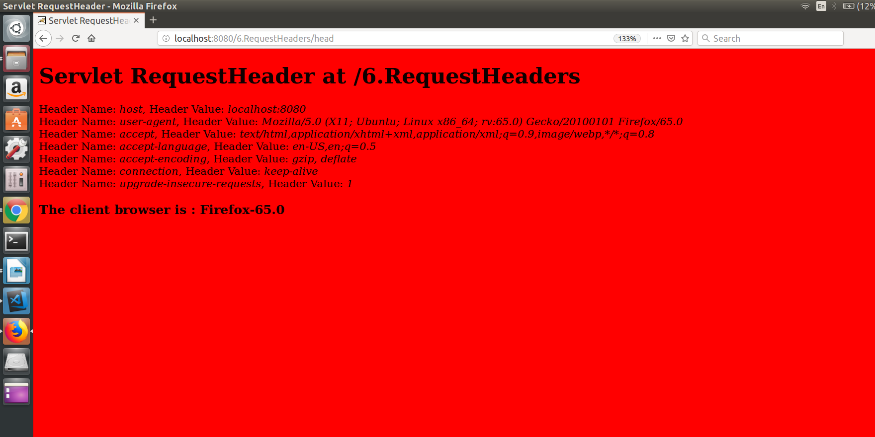

Result:
Thus the program is executed and output is obtained.

PROGRAM 7:

Aim:
To write a servlet that returns a Bad Request error page(400) unless the user supplies email-id without @ symbol in the form.

PROGRAM :

Form.html

<html>

<body>

<form action="bad" method="GET">

Username :<input type="text" name="username"><br>
Regno :<input type="text" name="regno"><br>
E-mail :<input type="text" name="email"><br>

<input type="submit" name="submit" value="SUBMIT">
</form>

</body>

</html>

MyServlet.java

import java.io.*;
import javax.servlet.*;
import javax.servlet.http.*;
import java.util.*;

public class MyServlet extends HttpServlet {

public void doGet(HttpServletRequest request, HttpServletResponse response) throws ServletException, IOException
{
response.setContentType("text/html");

PrintWriter out = response.getWriter();

String user = request.getParameter("username");
String regno = request.getParameter("regno");
String email = request.getParameter("email");

if (email.contains("@") == false)
response.sendError(400, "Bad Request");
else
{
out.println(user + "<br>");
out.println(regno + "<br>");
out.println(email + "<br>");

}
}

}

web.xml

<web-app>
<servlet>
<servlet-name>myservlet</servlet-name>
<servlet-class>MyServlet</servlet-class>
</servlet>
<servlet-mapping>
<servlet-name>myservlet</servlet-name>
<url-pattern>/bad</url-pattern>
</servlet-mapping>
</web-app>

OUTPUT :

Sample Ouput 1 :

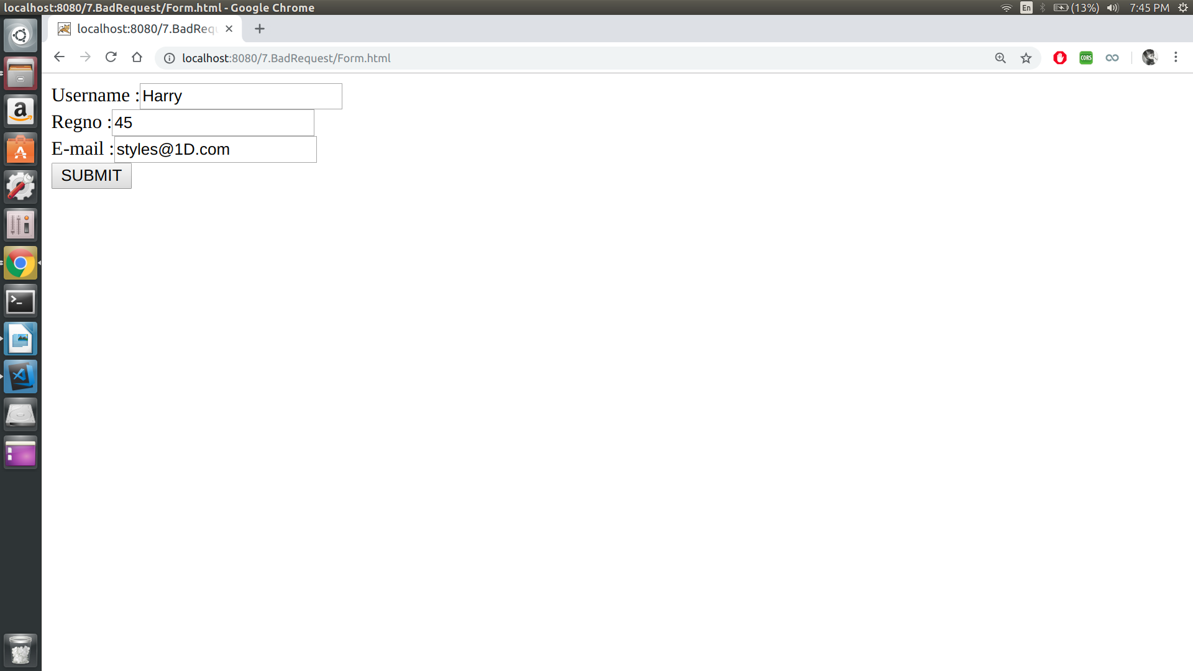
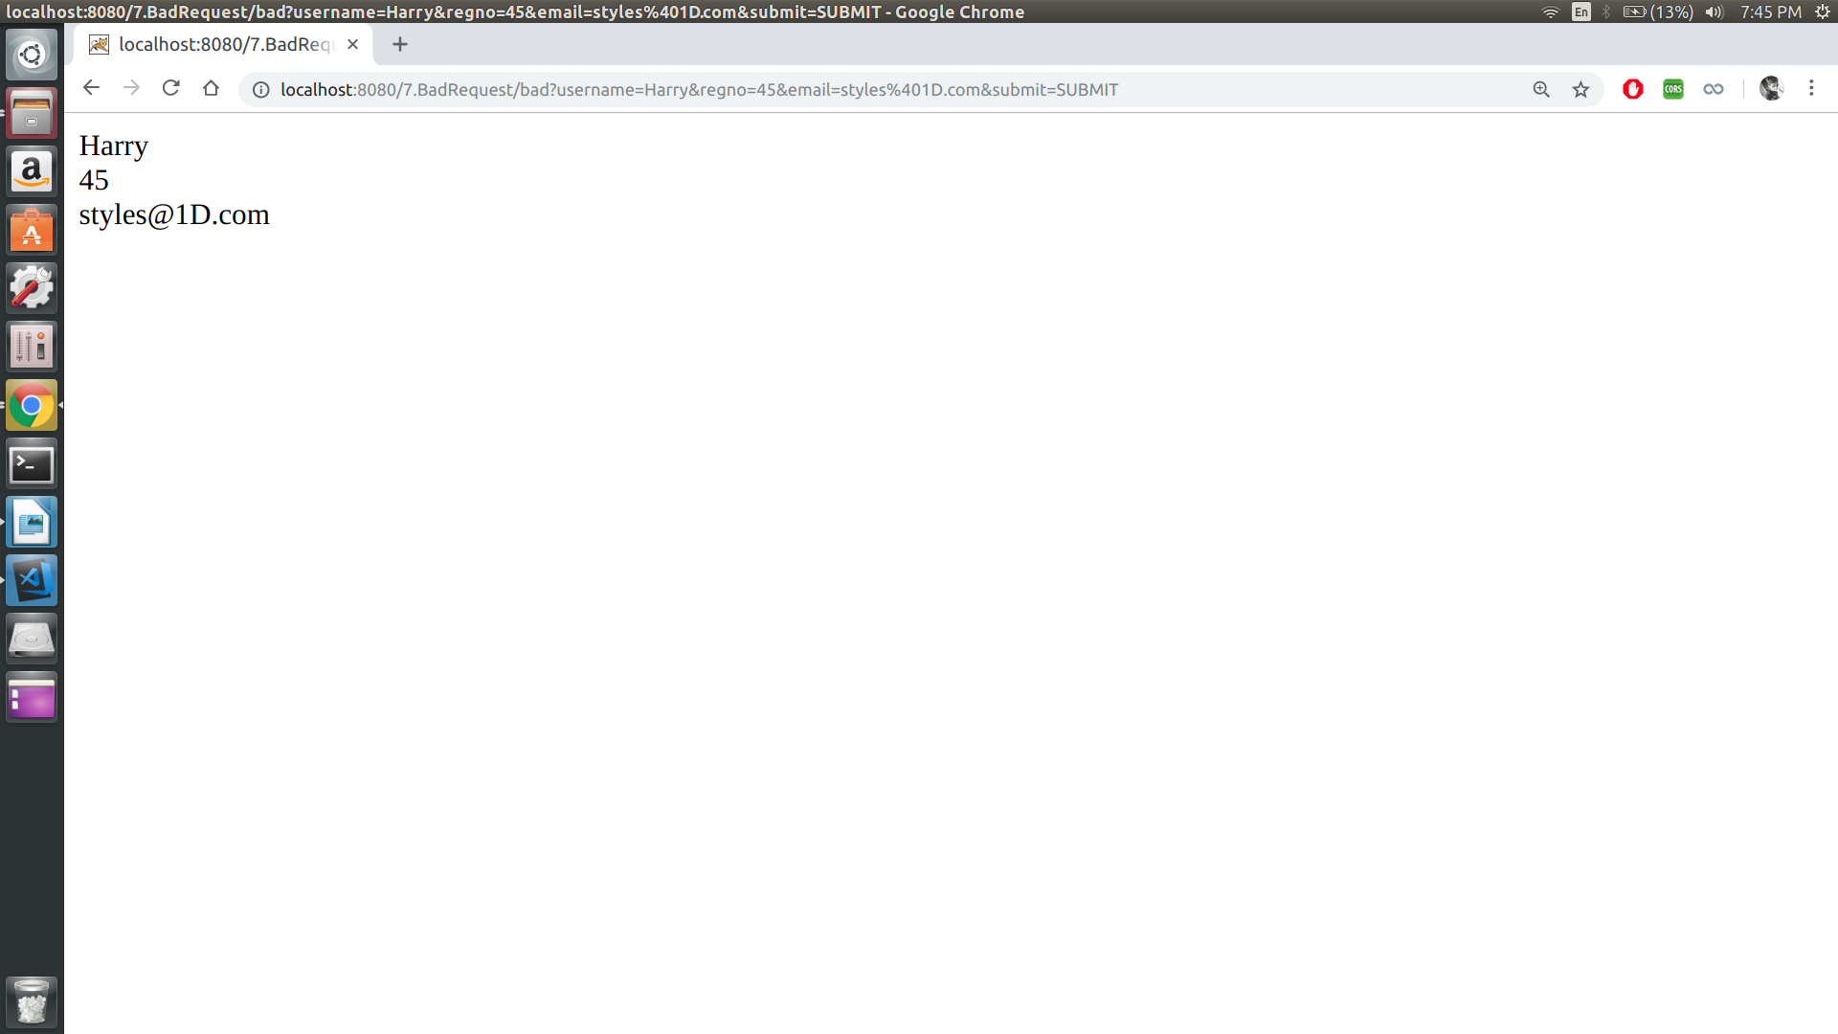

Sample Output 2 :

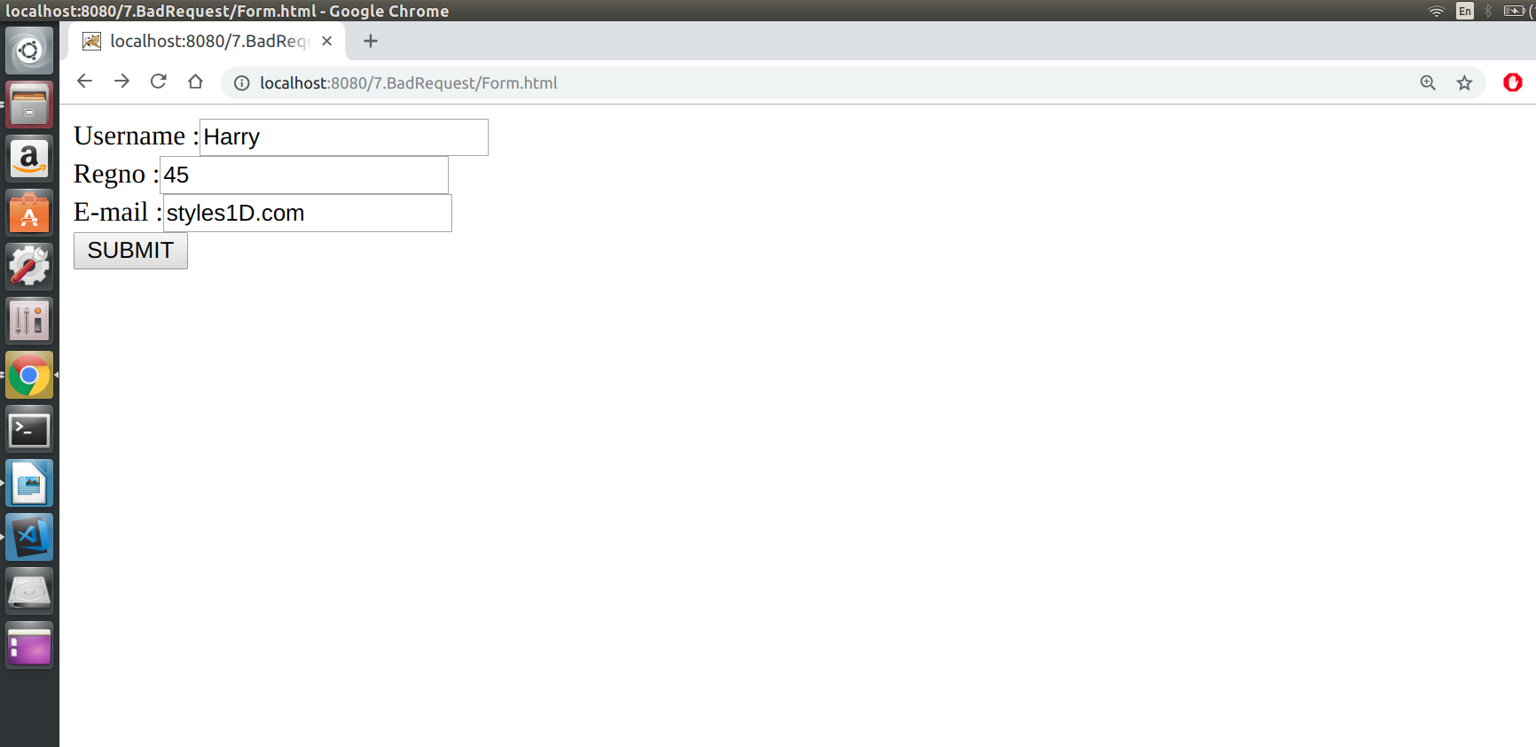

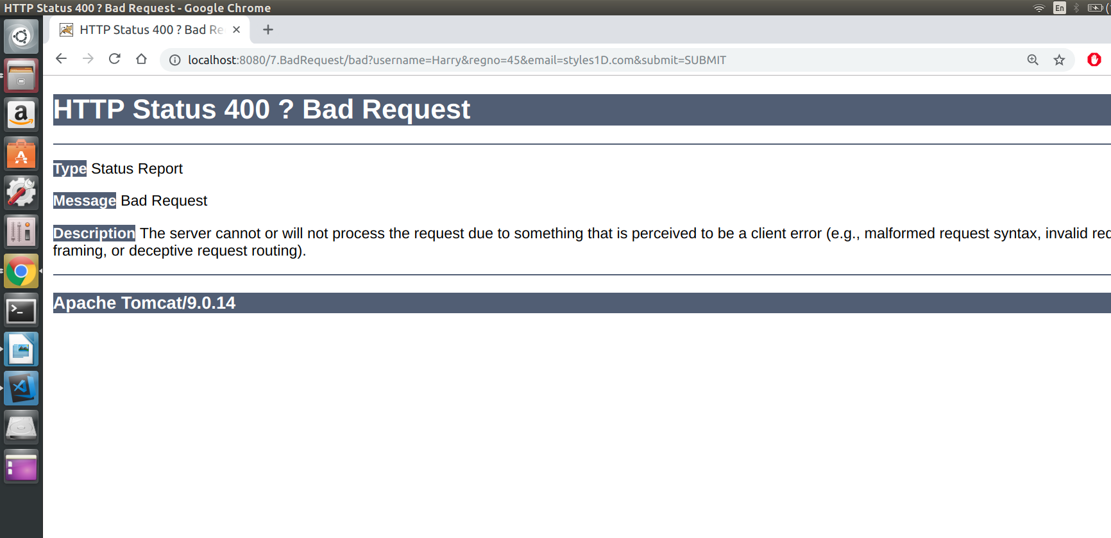

Result:
Thus the program is executed and output is obtained.

PROGRAM 8:

AIM :
To write a servlet that redirects a new servlet (named errorServlet) if the user supplies email-id without @ symbol in the form.

PROGRAM :

Form.html

<html>
<body>
<form action="pg1" method="GET">
Username :<input type="text" name="username"><br>
Regno :<input type="text" name="regno"><br>
E-mail :<input type="text" name="email"><br>

<input type="submit" name="submit" value="SUBMIT">
</form>
</body>
</html>

Servlet1.java

import java.io.*;
import javax.servlet.*;
import javax.servlet.http.*;
import java.util.*;

public class MyServlet extends HttpServlet {

public void doGet(HttpServletRequest request, HttpServletResponse response)
throws ServletException, IOException {
response.setContentType("text/html");

PrintWriter out = response.getWriter();

String user = request.getParameter("username");
String regno = request.getParameter("regno");
String email = request.getParameter("email");

if (email.contains("@") == false) {
RequestDispatcher rd = request.getRequestDispatcher("/pg2");
rd.forward(request, response);
} else {
out.println(user + "<br>");
out.println(regno + "<br>");
out.println(email + "<br>");

}
}
}

Servlet2.java

import javax.servlet.*;
import javax.servlet.http.*;
import java.io.*;

public class MyServlet1 extends HttpServlet {
public void doGet(HttpServletRequest request, HttpServletResponse response)throws ServletException, IOException {
response.setContentType("text/html");
PrintWriter out = response.getWriter();
out.println("@ missing");

}
}

web.xml

<web-app>
<servlet>
<servlet-name>myservlet</servlet-name>
<servlet-class>Servlet1</servlet-class>
</servlet>
<servlet-mapping>
<servlet-name>myservlet</servlet-name>
<url-pattern>/pg1</url-pattern>
</servlet-mapping>

<servlet>
<servlet-name>myservlet1</servlet-name>
<servlet-class>Servlet2</servlet-class>
</servlet>
<servlet-mapping>
<servlet-name>myservlet1</servlet-name>
<url-pattern>/pg2</url-pattern>
</servlet-mapping>
</web-app>

OUTPUT :

Sample Output 1 :

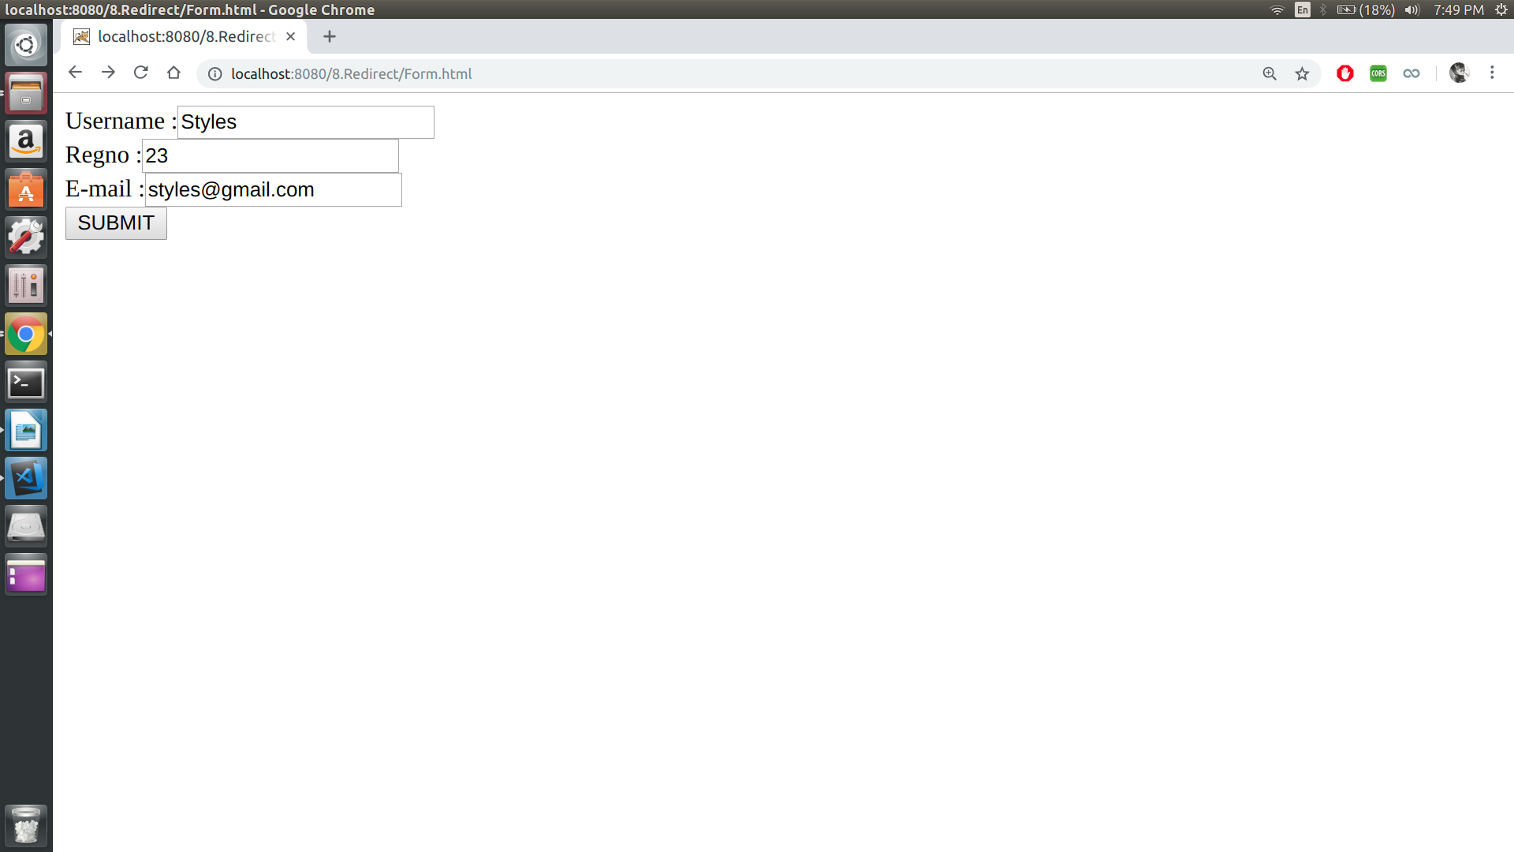
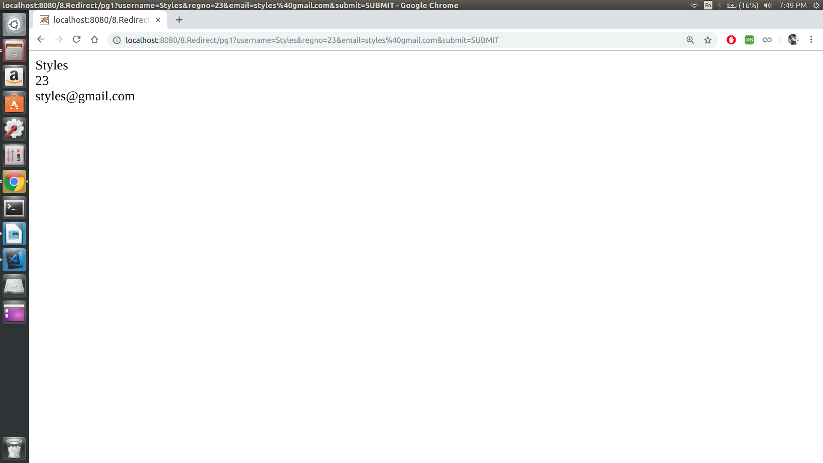

Sample Output 2 :

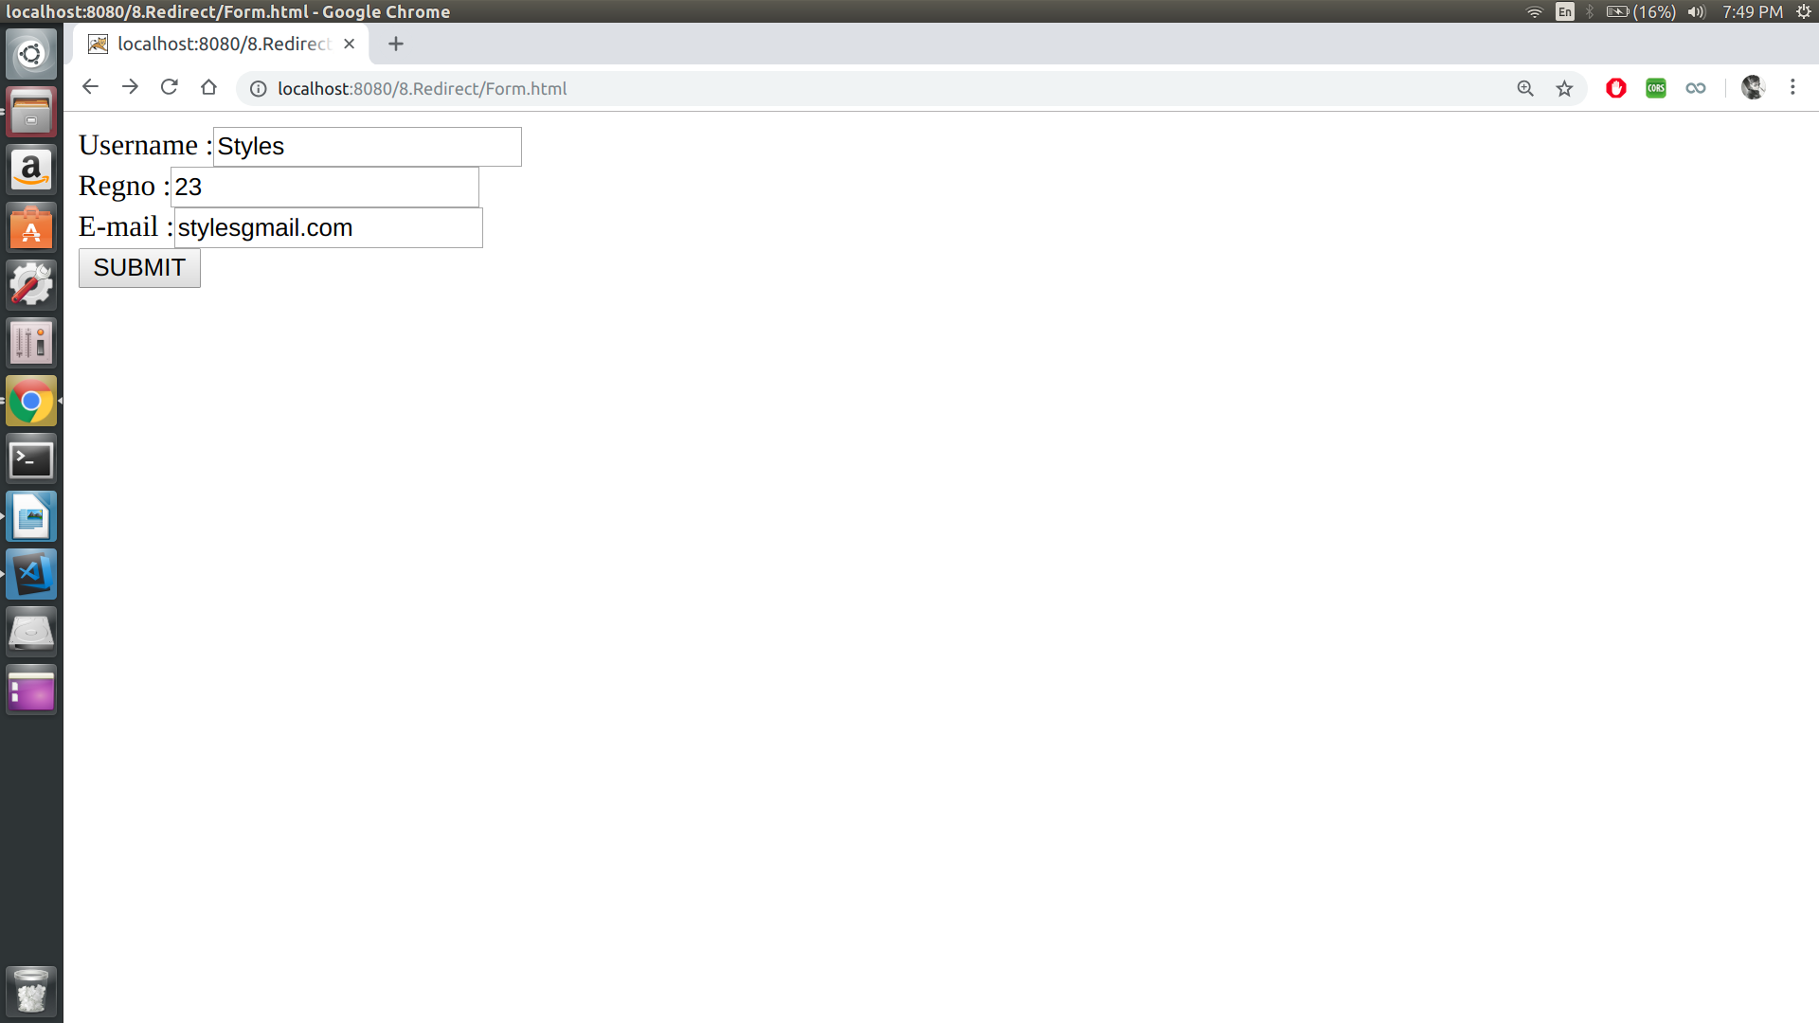
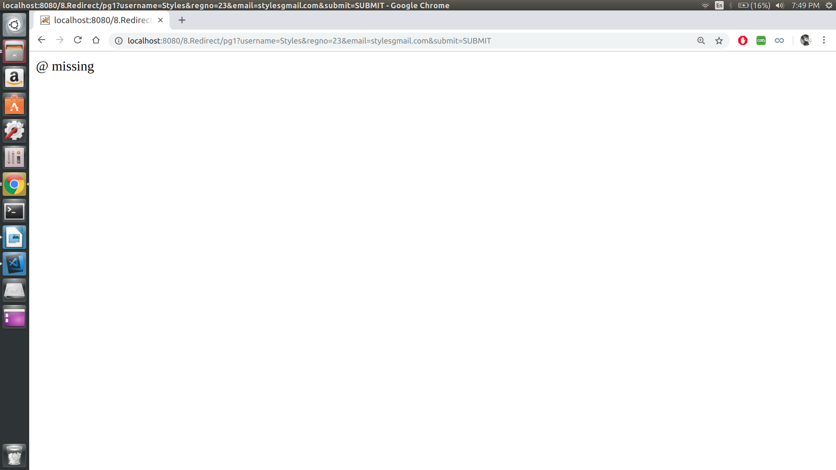
Result:
Thus the program is executed and output is obtained.

